# 

# 

# 

# **BattleX-PokemonTCG Game**

# **User Manual**

*Version: 1.0* *Designed for 2 Players* *Created By:* ***Arnab Das Utsa***

## **Index**

**Items Page**

### **1. Introduction —-------------------------------------------------------------------------- 3**

1.1 Overview of the Game —------------------------------------------------- 3

### **2. Pokémon Card Rules —------------------------------------------------------------ 5-6**

2.1 Game Setup —-------------------------------------------------------------- 5

2.2 Winning Conditions —------------------------------------------------------ 6

### **3. Game Flow —---------------------------------------------------------------------------- 7-8**

3.1 Starting the Game —------------------------------------------------------- 7

3.2 Step-by-Step Game Initialization —------------------------------------- 8

3.3 Taking a Turn —-------------------------------------------------------------- 8

### **4. Card Types & Their Roles —------------------------------------------------------- 9**

4.1 Pokémon Cards —---------------------------------------------------------- 9

4.2 Trainer Cards —------------------------------------------------------------- 9

4.3 Energy Cards —------------------------------------------------------------- 9

### **5. Gameplay Mechanics —------------------------------------------------------------ 10**

5.1 Bench & Active Pokémon —--------------------------------------------- 10

5.2 Attacking & Damage Calculation —------------------------------------ 10

5.3 Status Effects —------------------------------------------------------------ 10

5.4 Prize Cards —--------------------------------------------------------------- 10

**6. User Interface Guide —------------------------------------------------------------ 11-27**

A. Menu Screen —------------------------------------------------------------- 11

B. Assign Player Names —-------------------------------------------------- 13

C. Coin Flip Screen —-------------------------------------------------------- 14

D. Game Screen Layout —-------------------------------------------------- 16

### **7. Additional Notes —----------------------------------------------------------------- 28**

# **1. Introduction**

Welcome to the Pokémon Card Game, a turn-based strategy game where two players battle using a deck of Pokémon, Trainer, and Energy cards. Each player will build a deck, play Pokémon, use Trainer cards, and attack their opponent to win.

Strategy matters! Manage your deck, energy, and Pokémon lineup to outsmart your opponent.

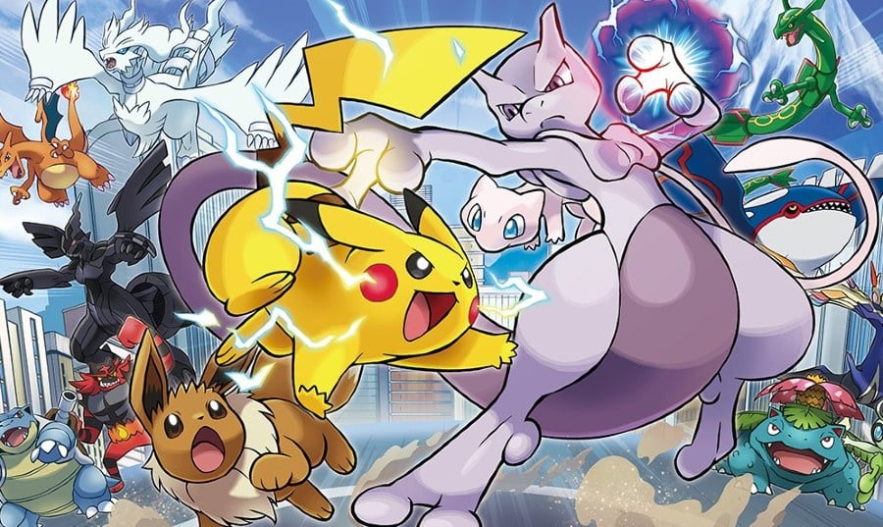

# **2.Pokémon Card Rules**

## 

## **2.1 Game Setup**

* Each player starts with a deck of shuffled cards.
* Each deck has 36 cards.
* Players enter their names in the Menu Screen.
* A coin flip determines who goes first.
* Each player draws 7 cards from their deck as their starting hand.
* Prize Cards: Each player places 3 cards in a separate Prize Pool.
* Players must choose an Active Pokémon before starting the game.
* The game begins.

***Note: If a player doesn’t have at least one Pokémon card in their opening hand, they must reshuffle and draw again***

## 

## 

## **2.2 Winning Conditions**

## **A player wins the game when one of the following occurs:**

## **2.2.1.** The player claims all 3 Prize Cards.

## Every time a Pokémon is defeated, the opponent claims one Prize Card.

## The first to claim all 3 Prize Cards wins.

## **2.2.2.** The opponent has no Pokémon left.

## If the opponent has no Active Pokémon and no Bench Pokémon, they lose immediately.

## **2.2.3.** The opponent’s deck runs out of cards.

## If a player needs to draw a card but their deck is empty, they lose automatically.

## 

## **3. Game Flow**

### **3.1 Starting the Game**

– Download the git repository → [Click the link](https://github.com/iUtsa/BattleX-PokemonTCG)

– Extract the zip file

– Launch java IDE ( IntelliJ, Eclipse, VS Code etc)

– Open the folder in IDE.

– Running “Main.java” opens the Main Menu.

**3.1.1.** Open the Main Menu.

**3.1.2.** Click “Start Game”.

**3.1.3.** Enter Player Names.

**3.1.4.** A coin flip decides the first turn.

**3.1.5.** Decks are shuffled, and 7 cards are drawn.

**3.1.6.** Each player selects an Active Pokémon and sets up their bench.

**3.1.7.** The gameboard loads, and the first player’s turn begins.

### 

### **3.2 Taking a Turn**

**Each player’s turn consists of the following steps:**

**3.2.1.** Draw a card from the deck (if available).

**3.2.2.** Perform any of the following actions:

* + Play a Pokémon to the Bench.
  + Attach Energy to a Pokémon.
  + Use a Trainer Card.
  + Attack the opponent’s Active Pokémon (if conditions are met).
  + End the turn.

**3.2.3.** The turn ends, and the next player begins.

### **3.3 Actions Available on a Turn**

* Play Pokémon: Move a Pokémon from hand to Bench.
* Attach Energy: Assign an Energy card to a Pokémon.
* Use Trainer Card: Apply a Trainer card’s effect.
* Attack: Use an Active Pokémon’s attack (requires enough Energy).
* End Turn: Pass play to the opponent.

## **4. Card Types & Their Roles**

### **4.1 Pokémon Cards**

* These are the main battle creatures.
* 4 cards in game : Pikachu, MewTwo, Charmander, Golem
* Each has HP (Health Points), Energy, and Attacks.
* Pokémon are either inActive or Bench position.
* When HP reaches 0, a Pokémon faints.

### **4.2 Trainer Cards**

* These provide special effects, like:
  + Healing a Pokémon (Potion).
  + Removing Status Effects (Full Heal).
  + Drawing 3 extra cards (Professor Oak).

### **4.3 Energy Cards**

* Energy is required to use Pokémon attacks.
* Each Pokémon attack costs a specific amount of Energy.
* Energy can be attached to Pokémon once per turn.

## **5. Gameplay Mechanics**

### **5.1 Bench & Active Pokémon**

* Players can hold multiple Pokémon on the Bench.
* The Active Pokémon is the one currently battling.
* If the Active Pokémon faints, a Bench Pokémon must replace it.

### **5.2 Attacking & Damage Calculation**

* Attacks reduce an opponent's HP.
* Each attack has damage and energy requirements.
* Pokémon faint when HP = 0.

### **5.3 Status Effects**

* Paralyze: Pokémon misses the next turn.
* Burn: Pokémon loses 10 HP per turn.
* Sleep: Pokémon has a 50% chance to wake up each turn.

### **5.4 Prize Cards**

* When an opponent’s Pokémon faints, the player claims a Prize Card.
* First to claim all Prize Cards wins.

## **6. User Interface Guide**

### **6.1. Menu Screen**

* **Start Game**: Begins a new match.

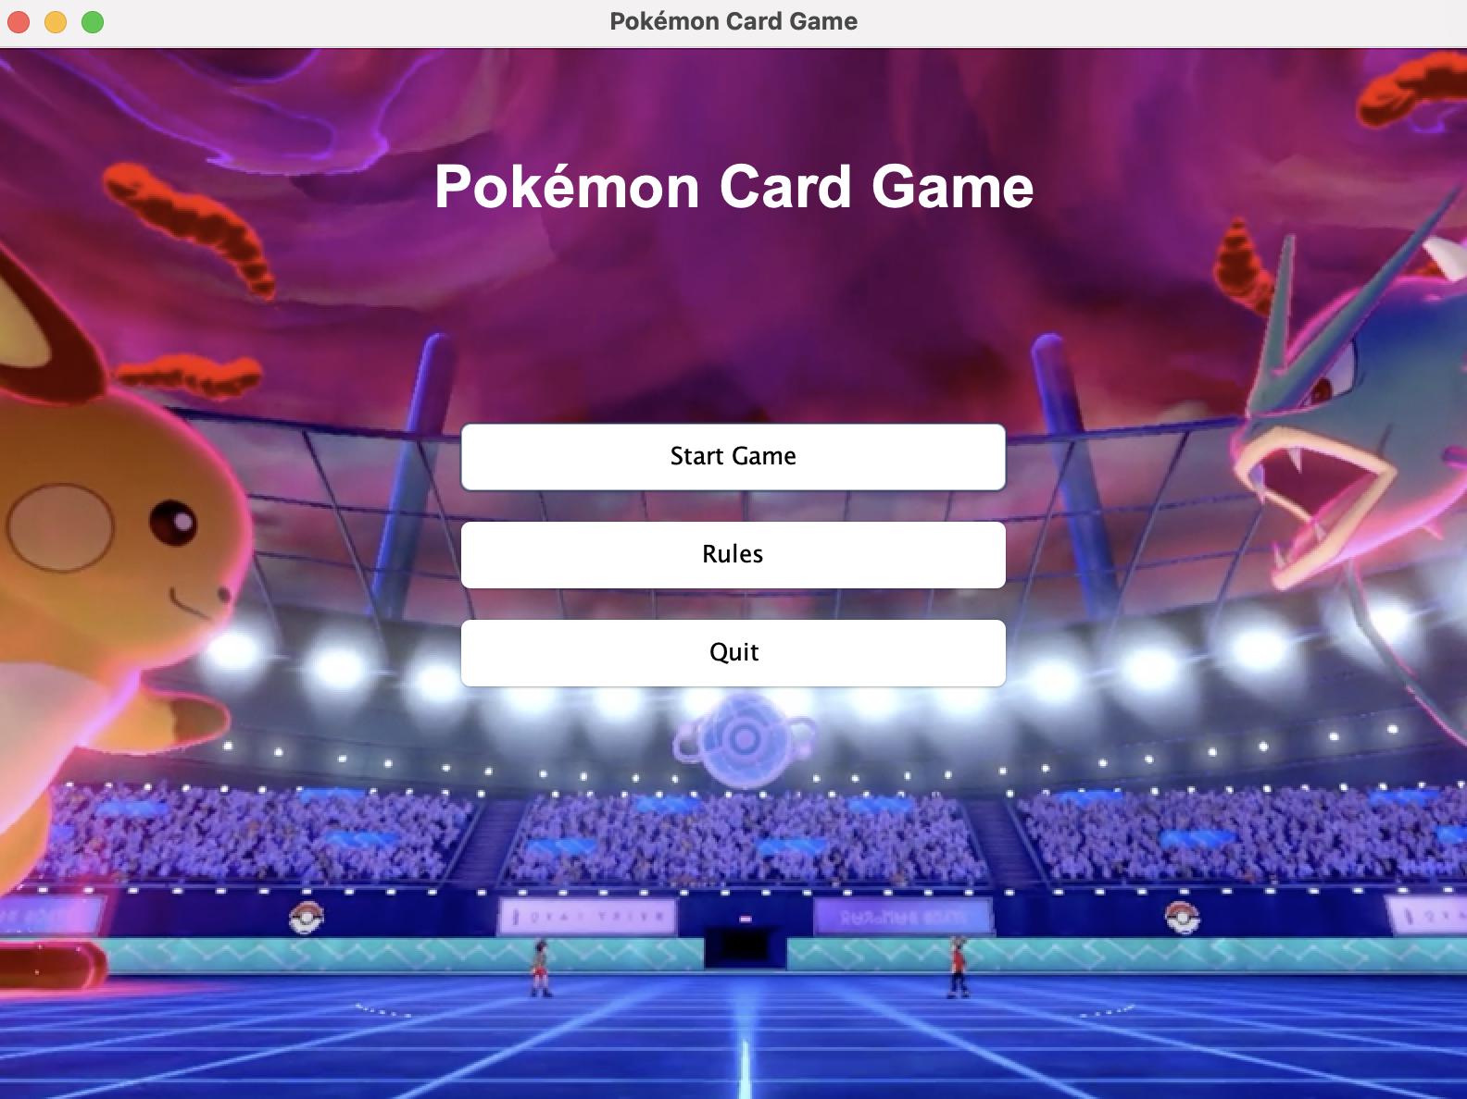

* **Rules:** Displays game rules.

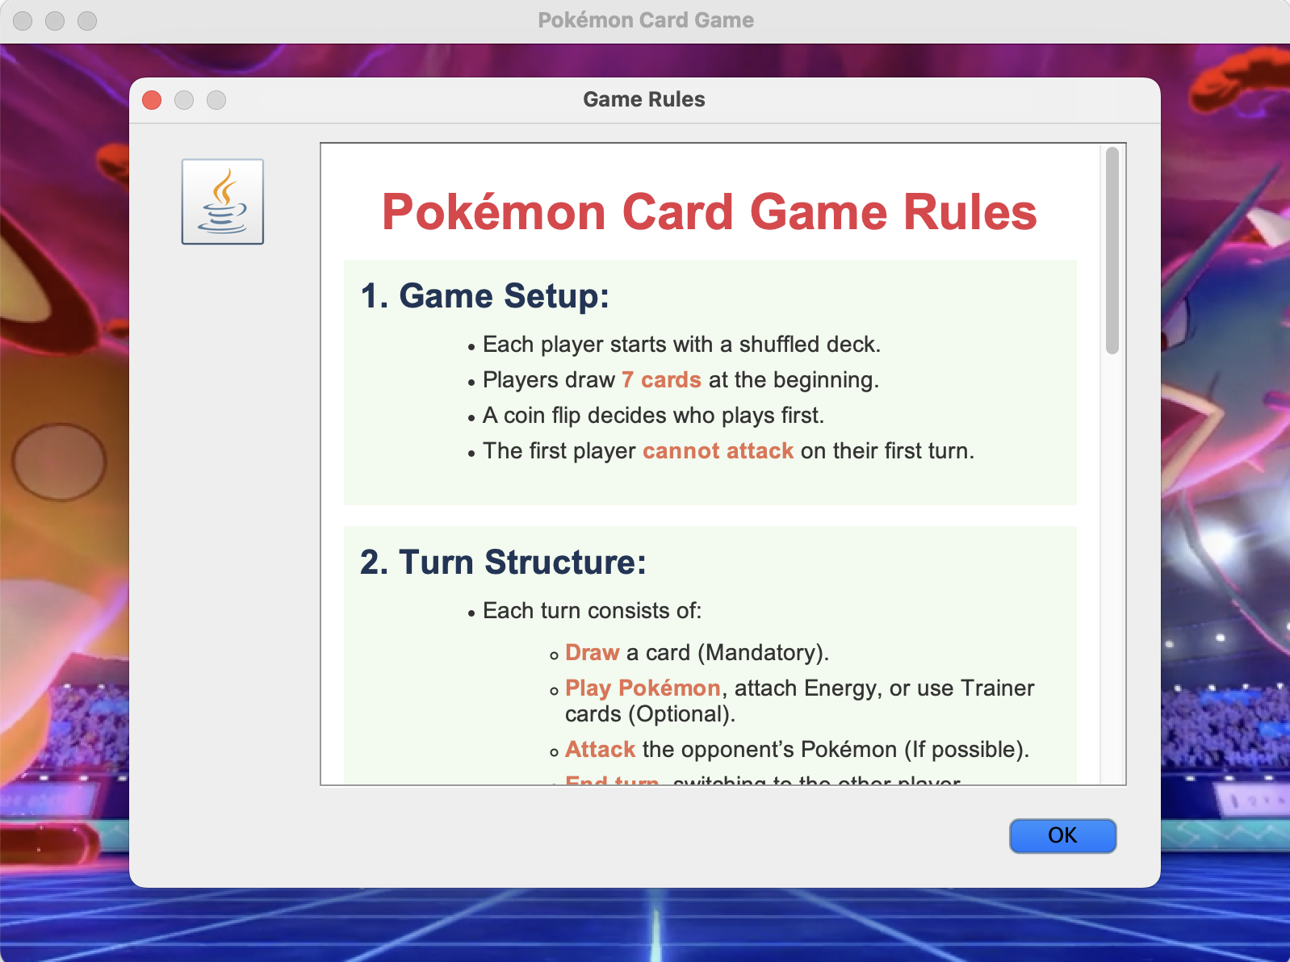

* **Quit**: Exits the game.

**6.2. Assign Player Names**

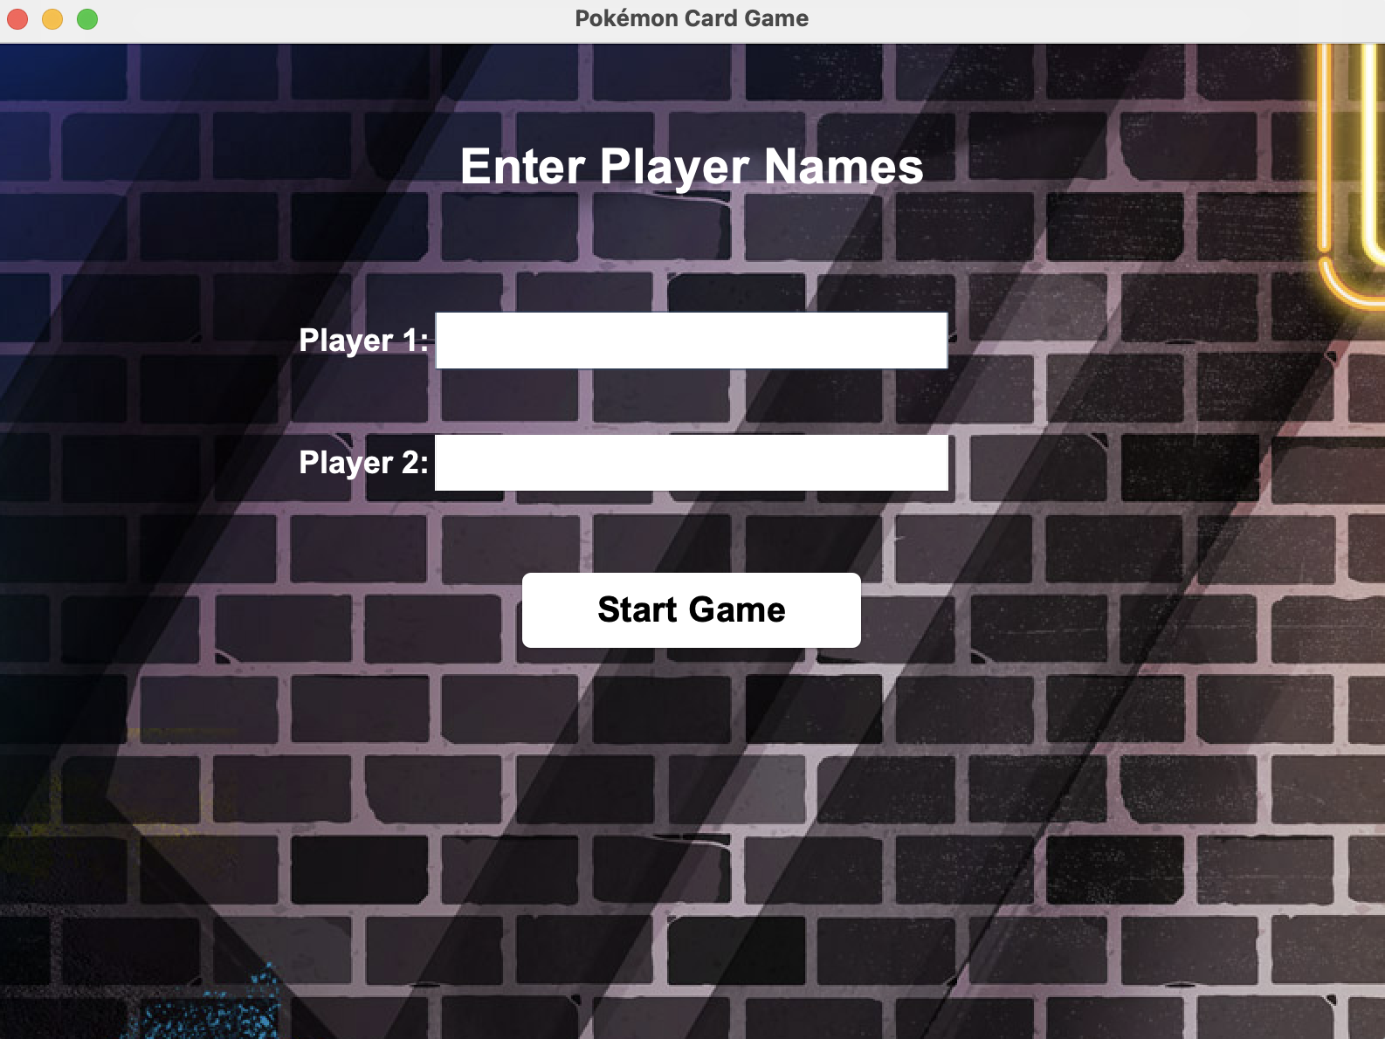

* Must enter name or it will show error message:

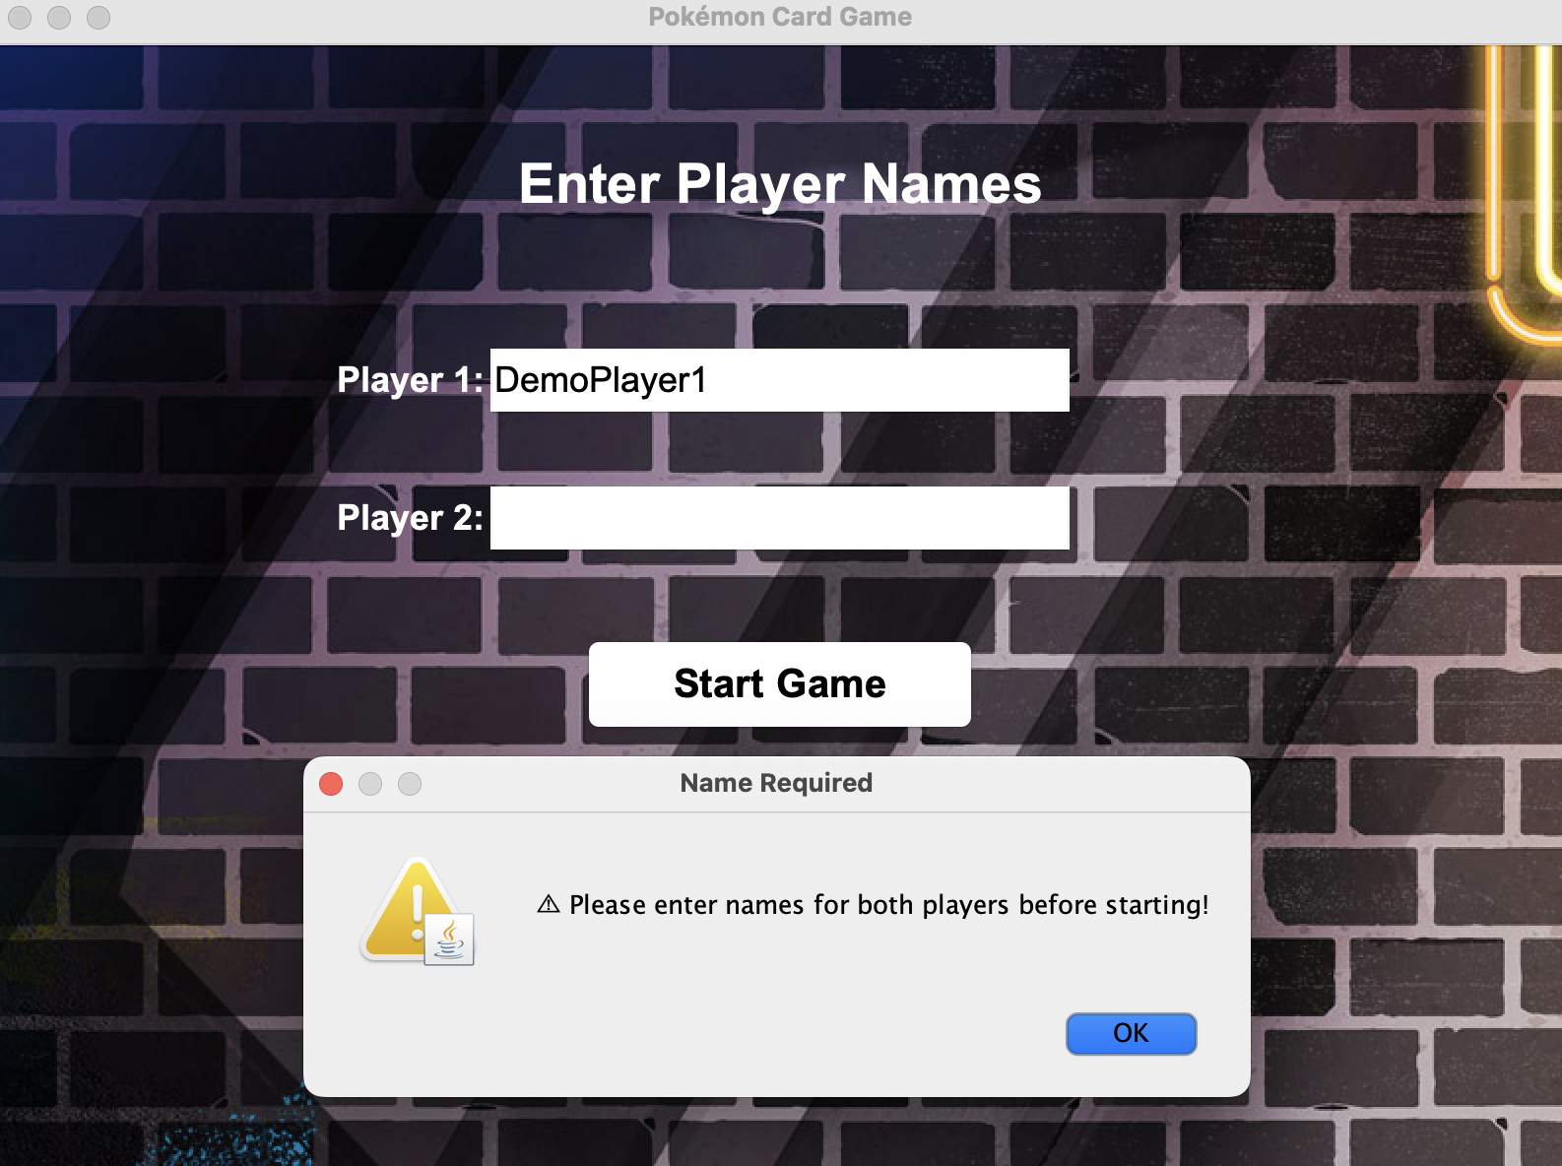

Enter Player name and Click “Start Game”:

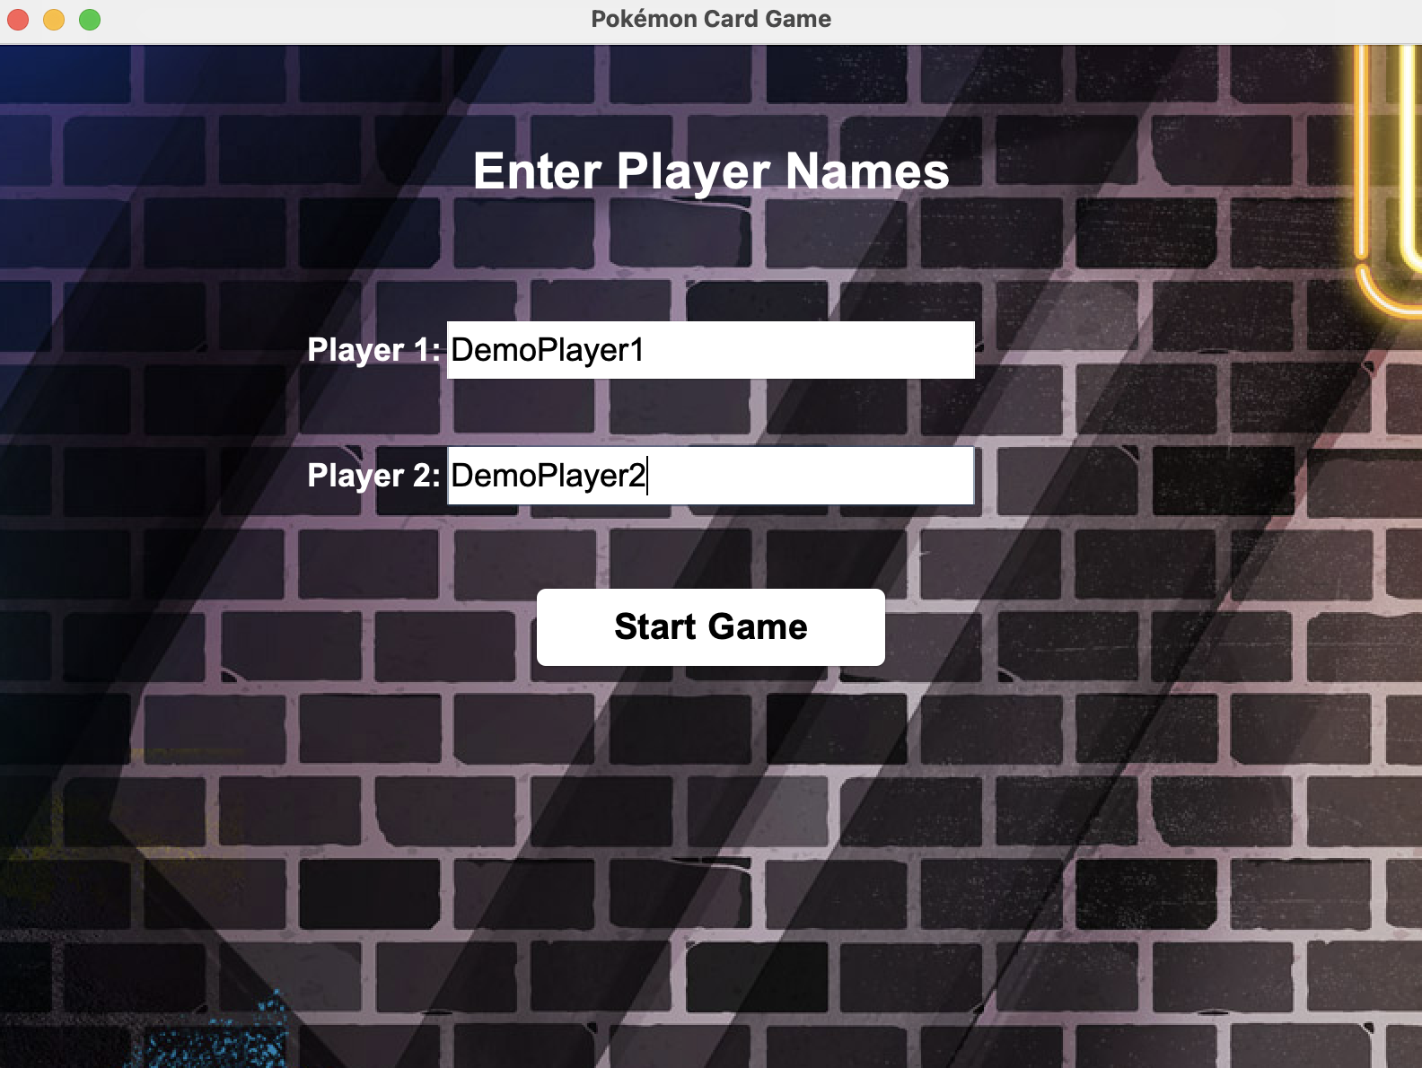

### **6.3. Coin Flip Screen**

* Players select "Heads" or "Tails".

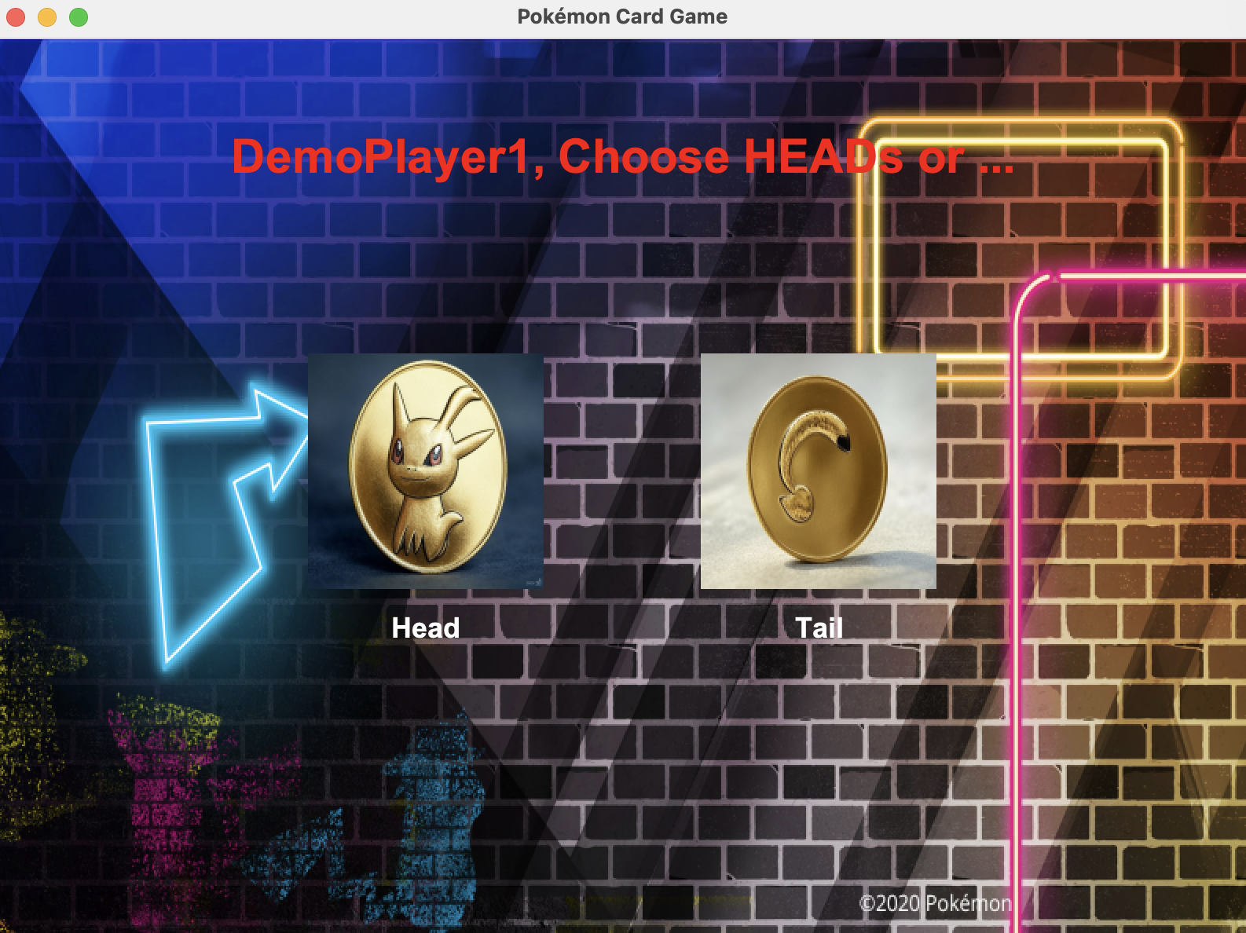

* A random coin flip determines the first player.

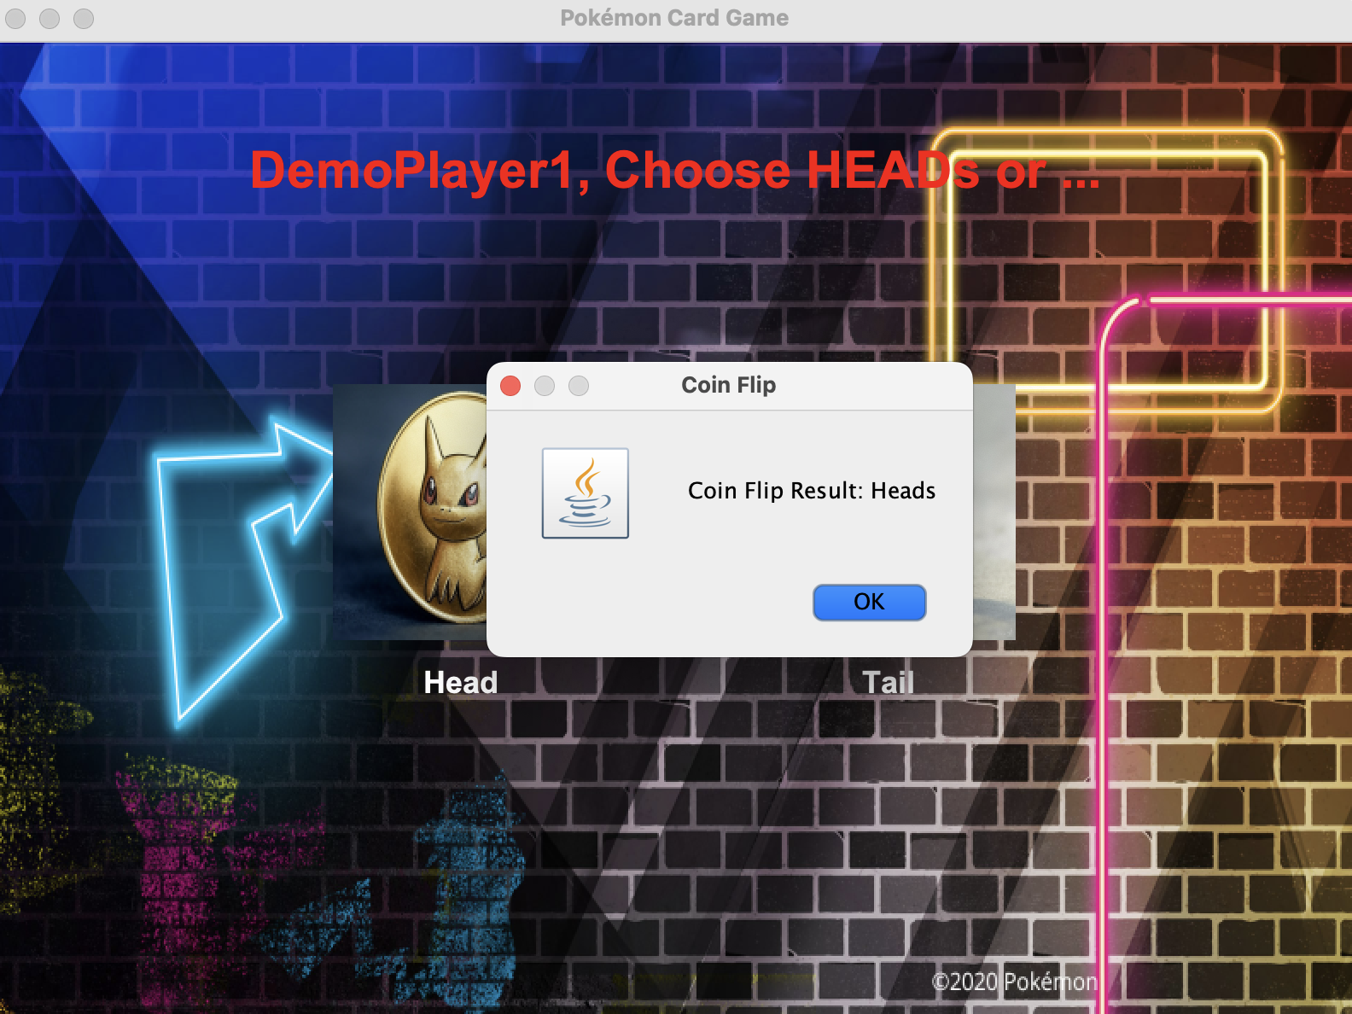

The real game begins with the first players turn:

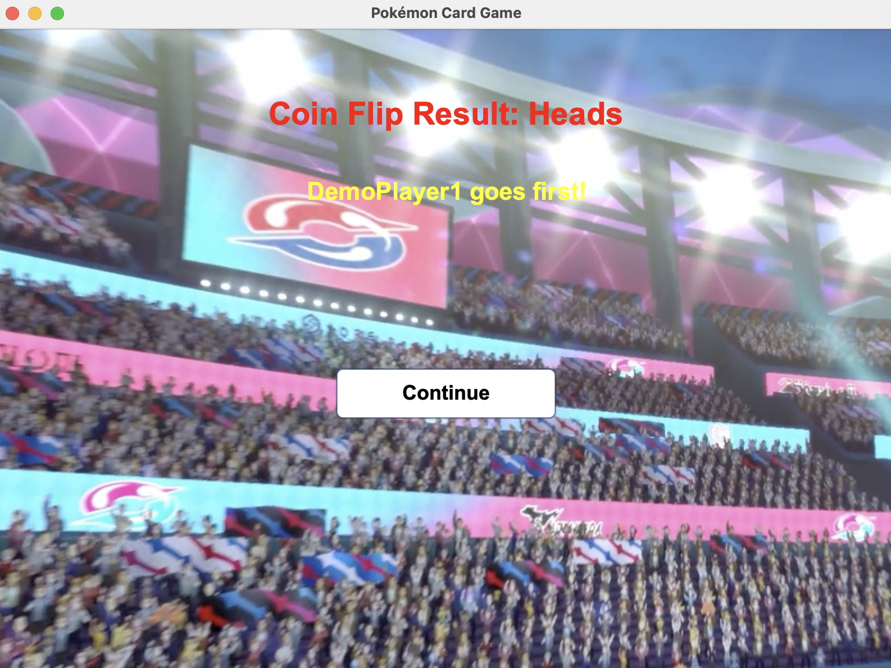

### **6.4. Game Screen**

#### **6.4.1. Top Display**

* Player’s Turn (Red text).
* Deck count (White text) and Prize Card (Yellow Text)
* Hand Display (Shows drawn cards).
* 8 buttons (each has unique functions)

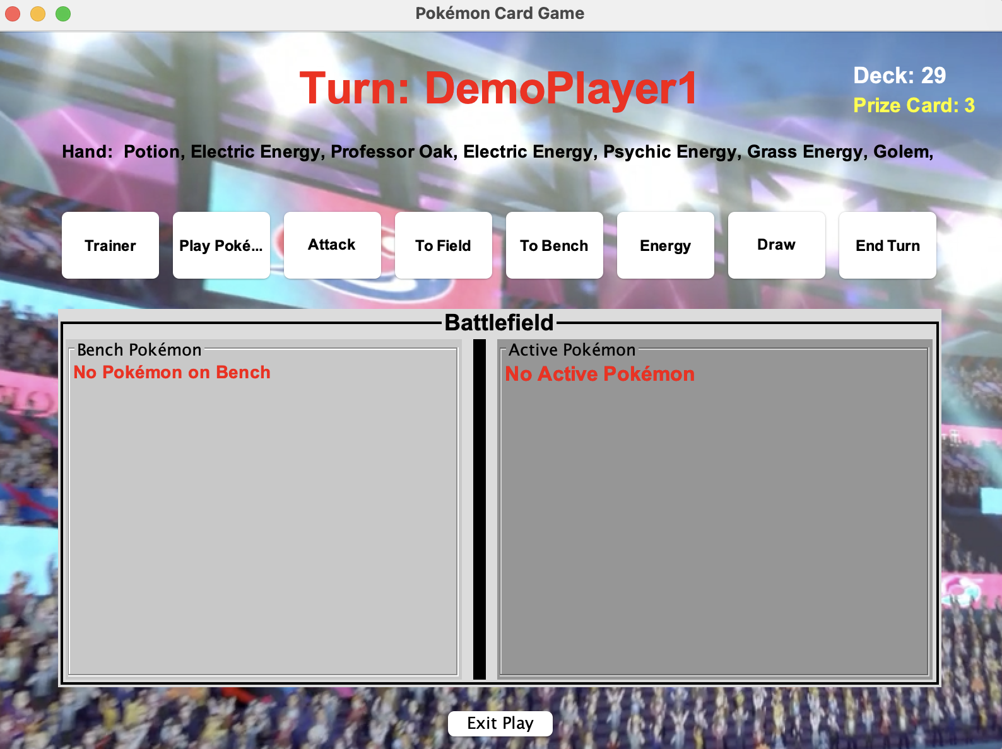



#### **6.4.2. Battlefield**

* Left Side: Bench Pokémon.
* Right Side: Active Pokémon.
* Exit Play Button



#### **6.4.3. Buttons & Actions**

* Play Pokémon (Adds 1st Pokémon to the battlefield upon choice).

***Player:1***

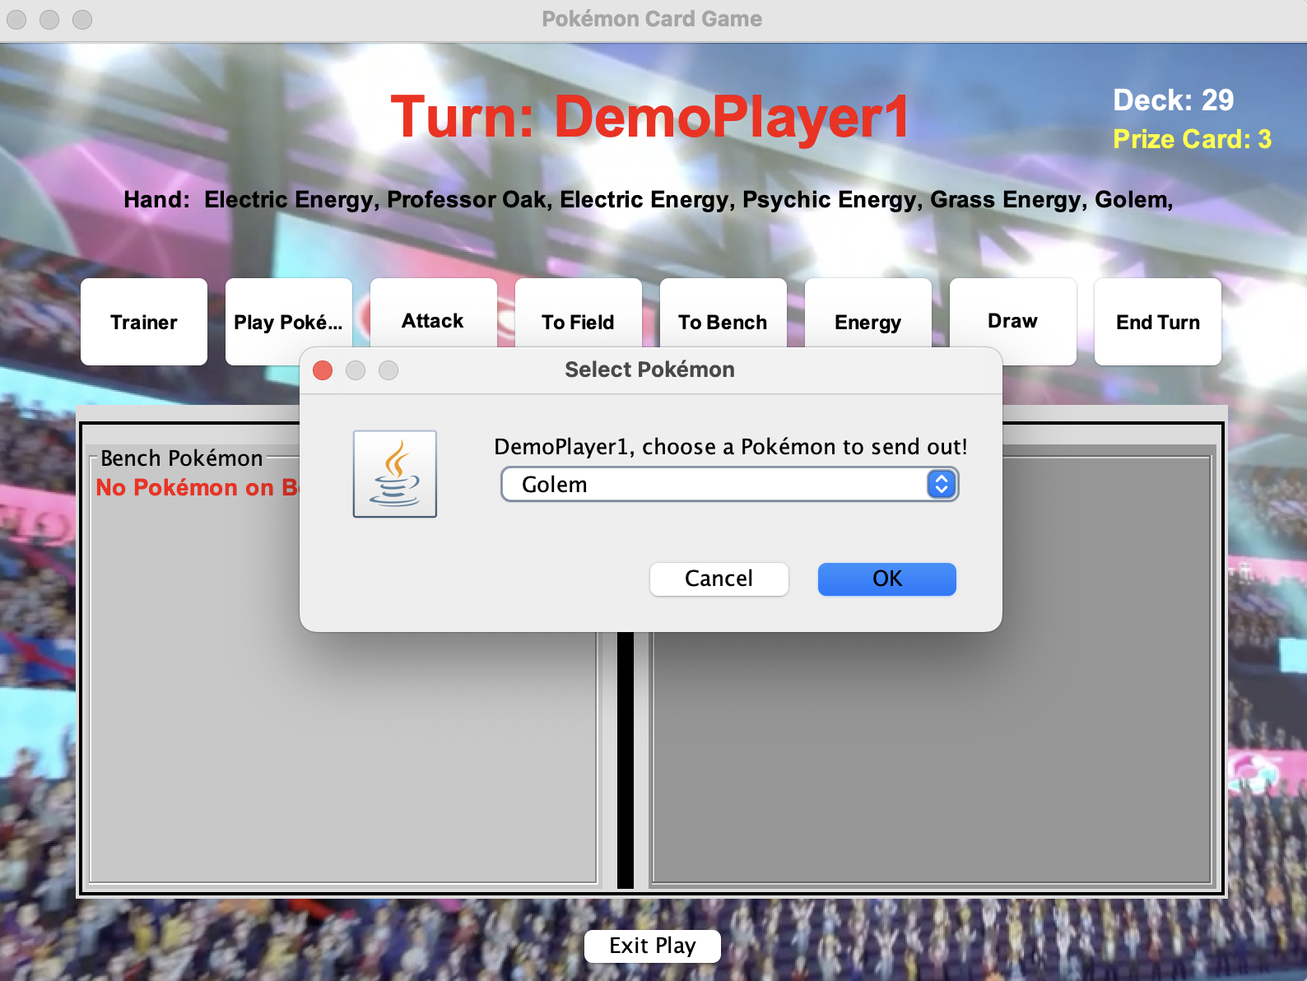

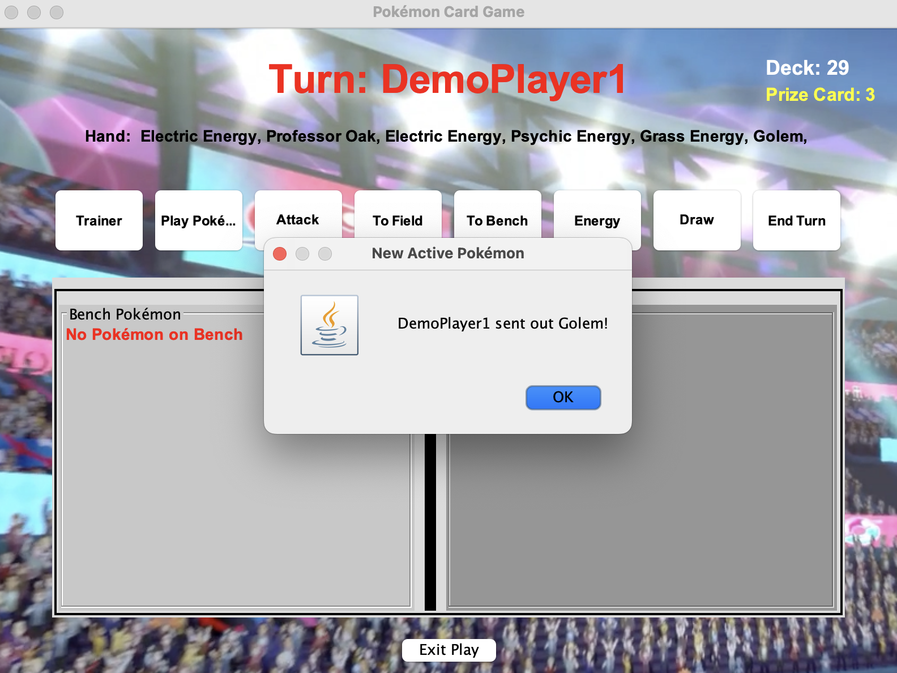

Pokemon Selected to battle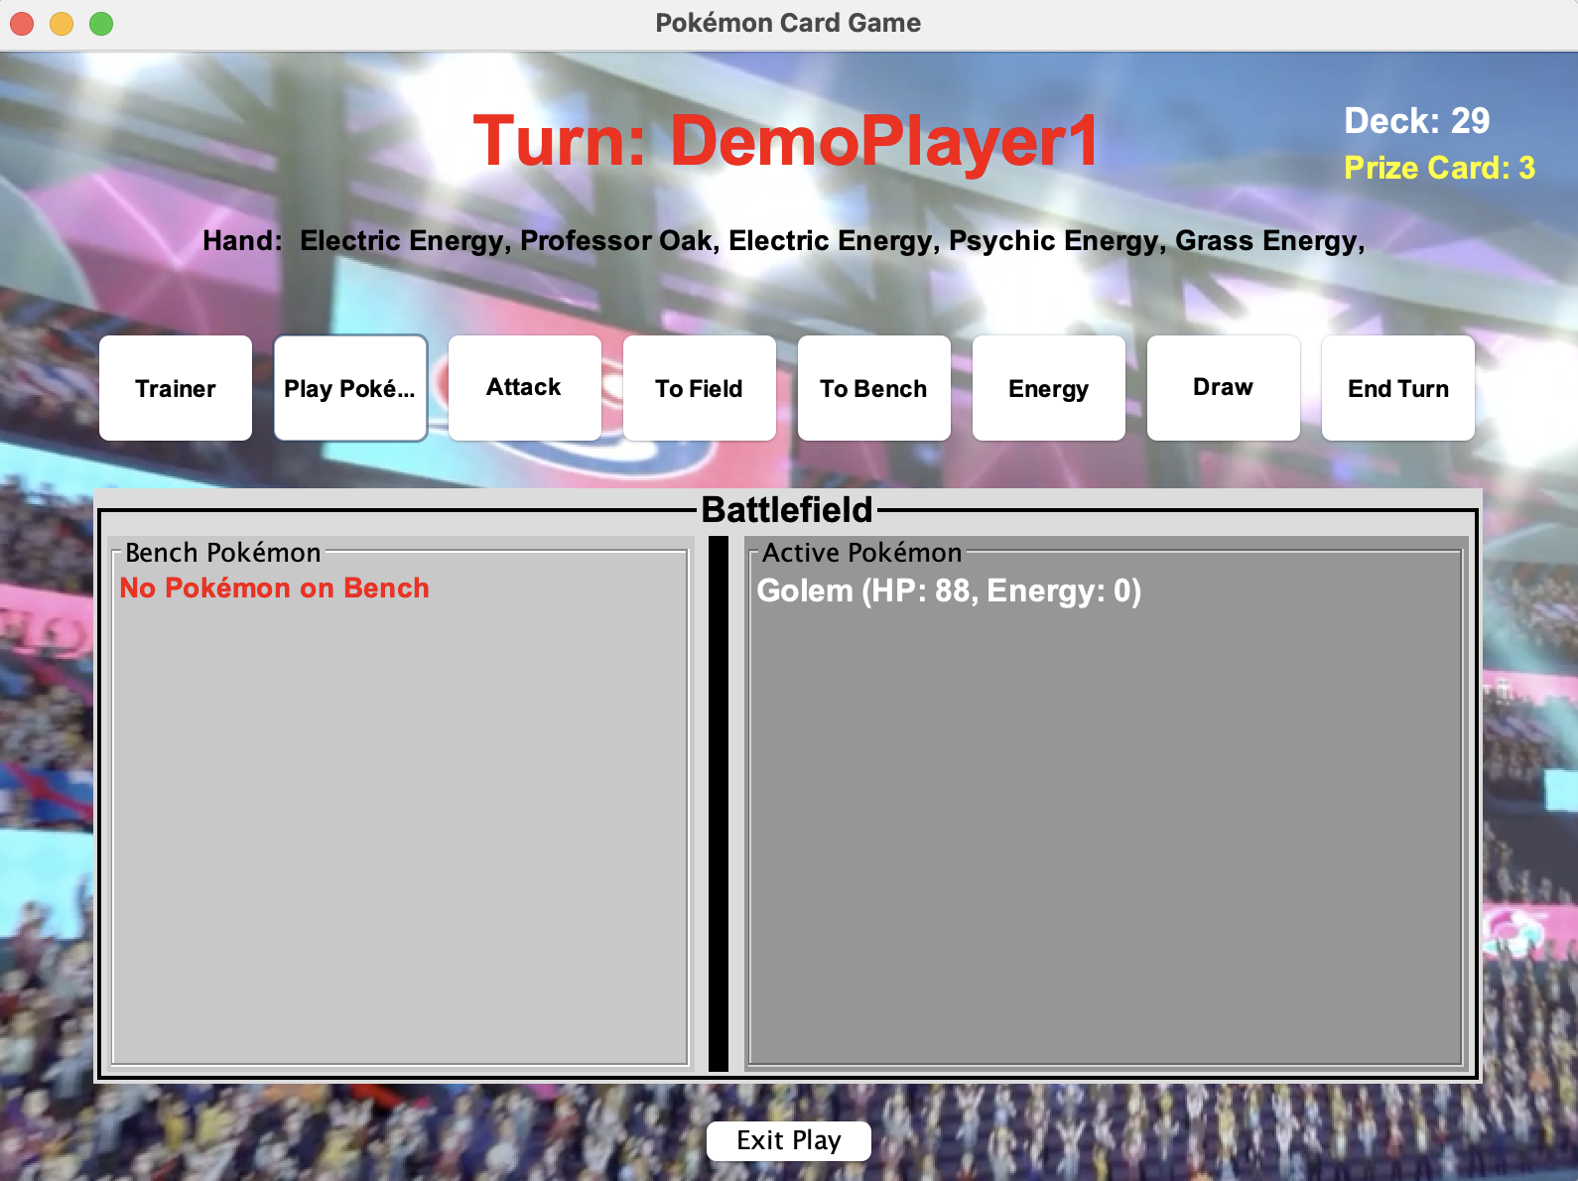

Pokemon Made active

***Player:2***

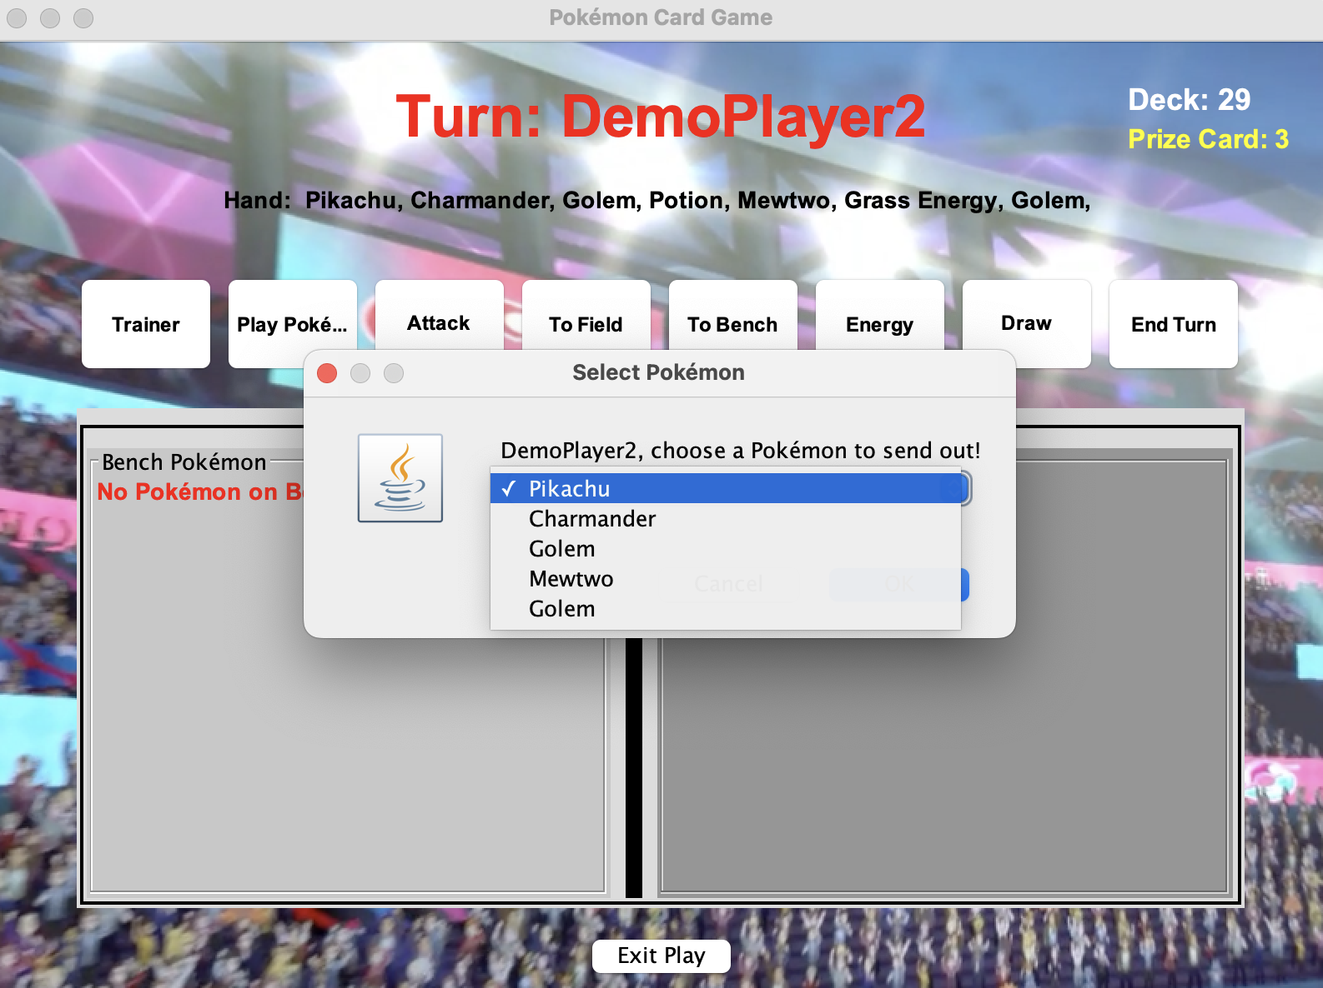

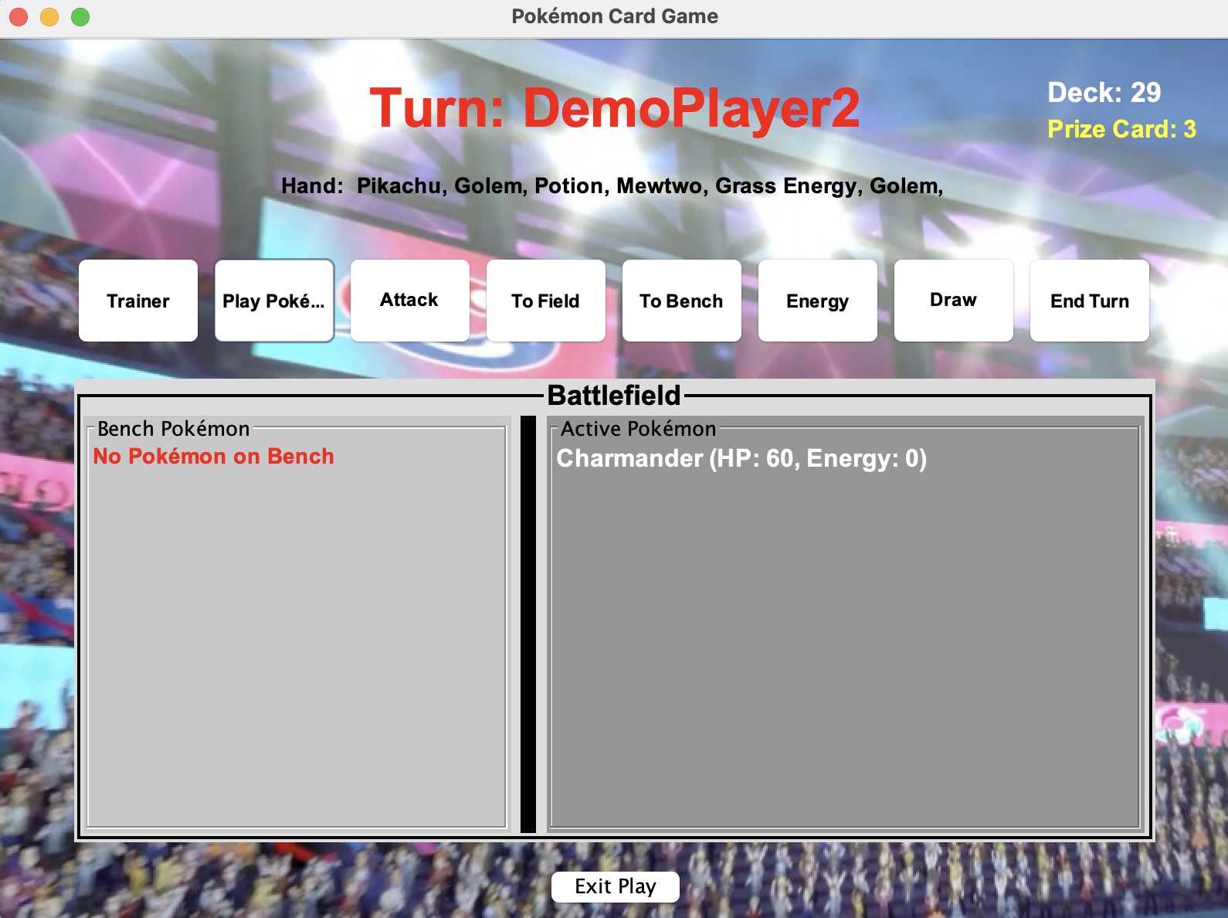

Player 2 selected Charmander

Cannot click play pokemon if a active pokemon is on battle, instead use to bench

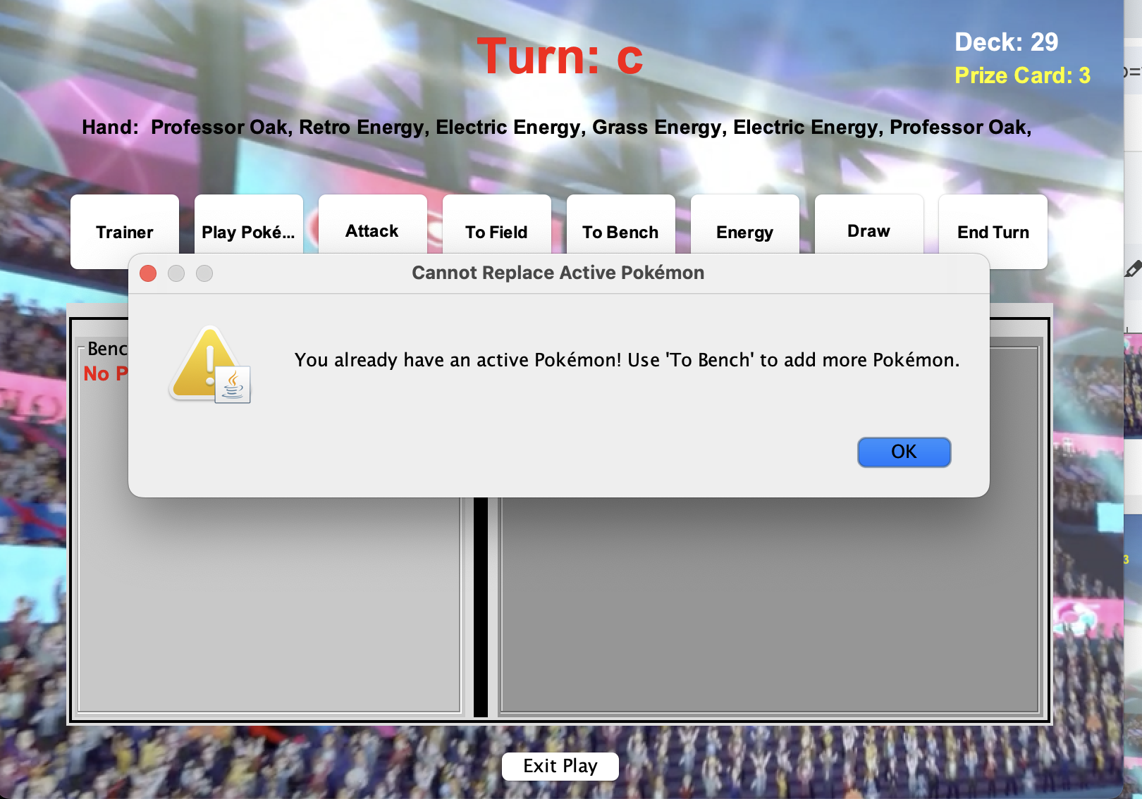

* To Field (Moves Pokémon to field from bench if no active pokemon).

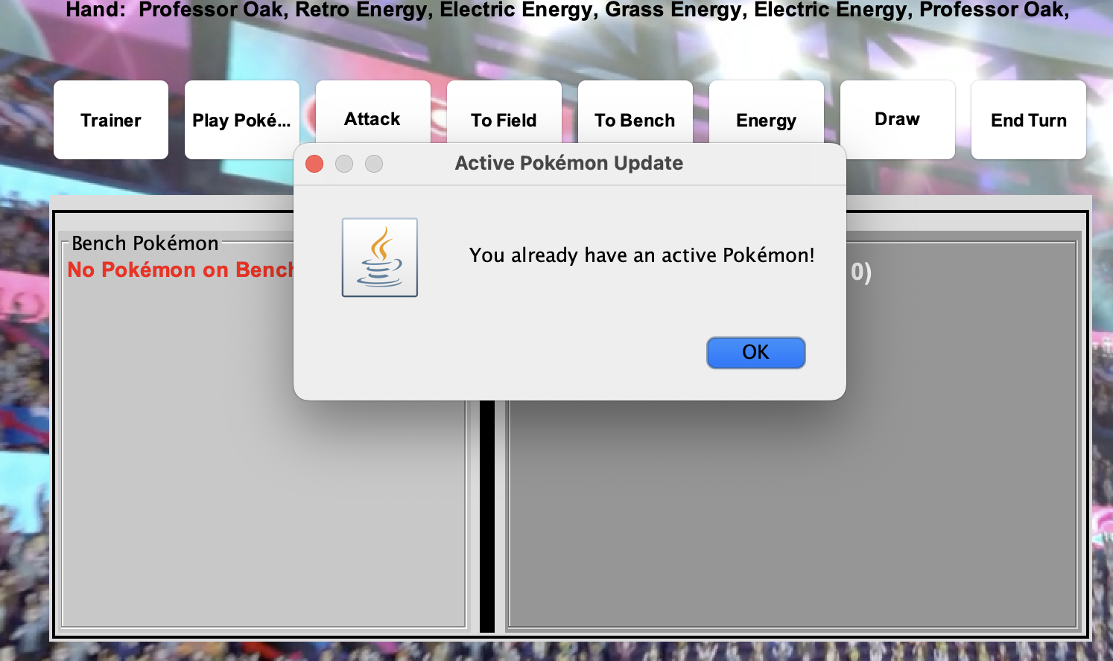

* Attach Energy (Adds Energy to a Pokémon).

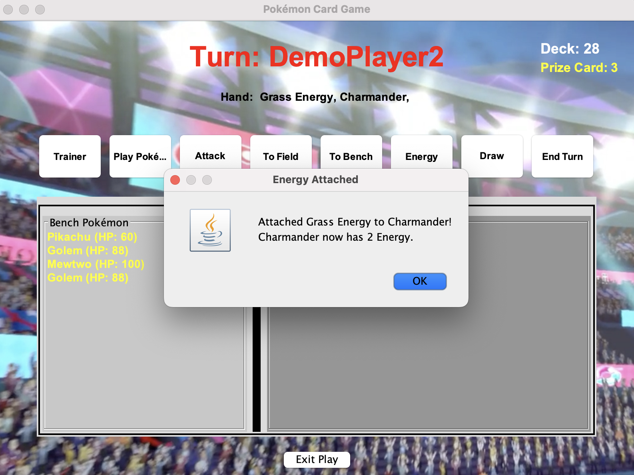

* Trainer Card (Activates special effects).

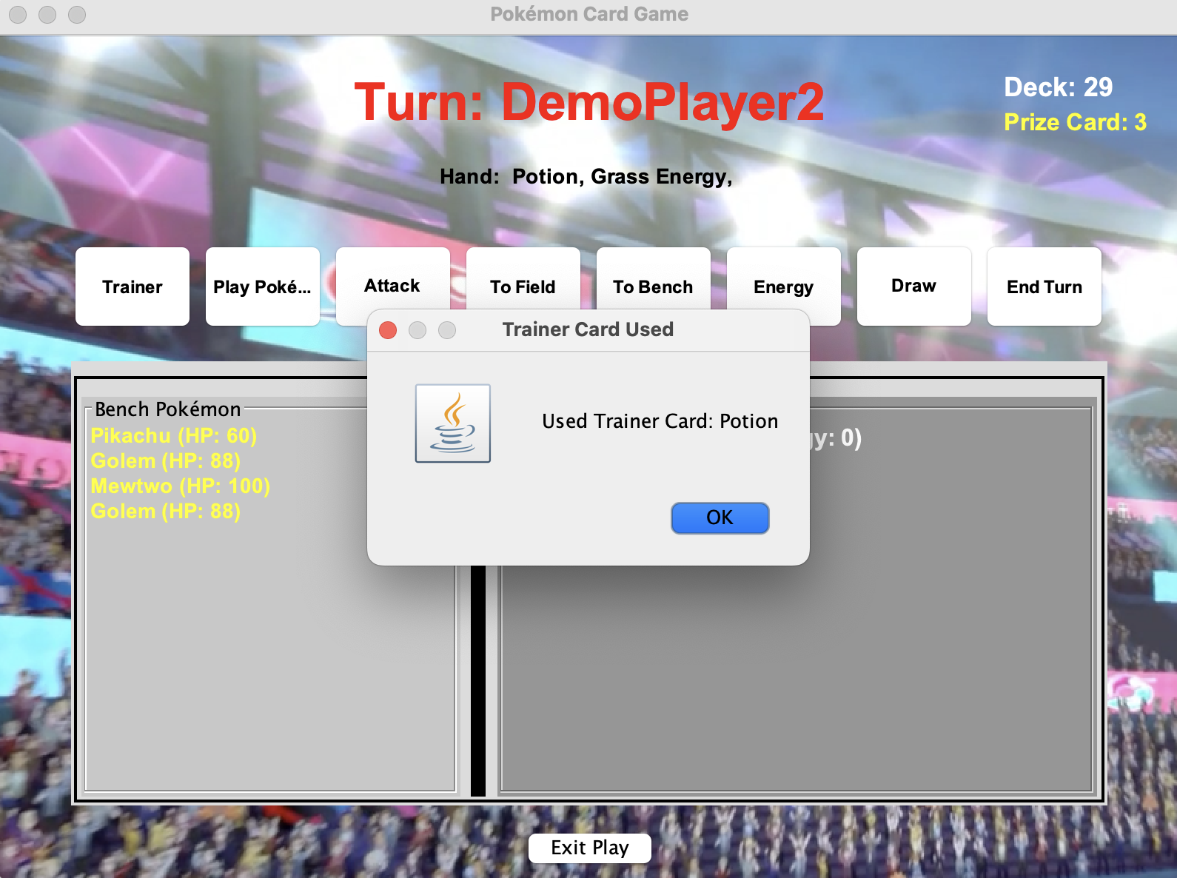

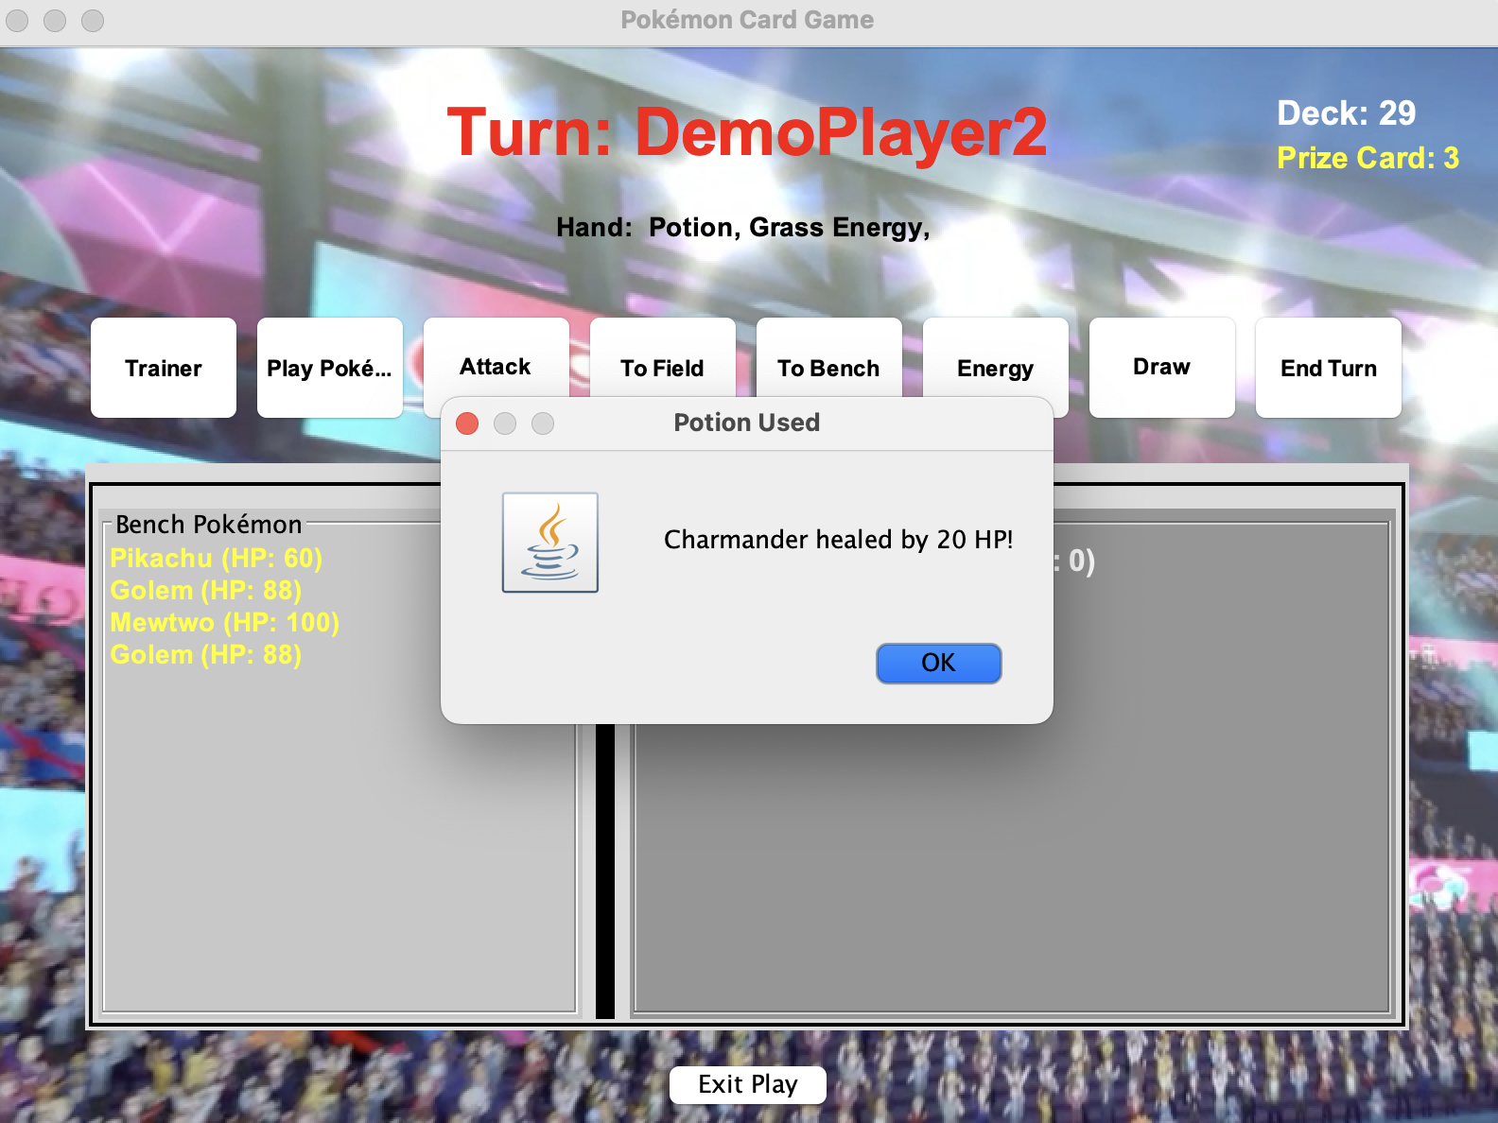

Potions Power has increased HP

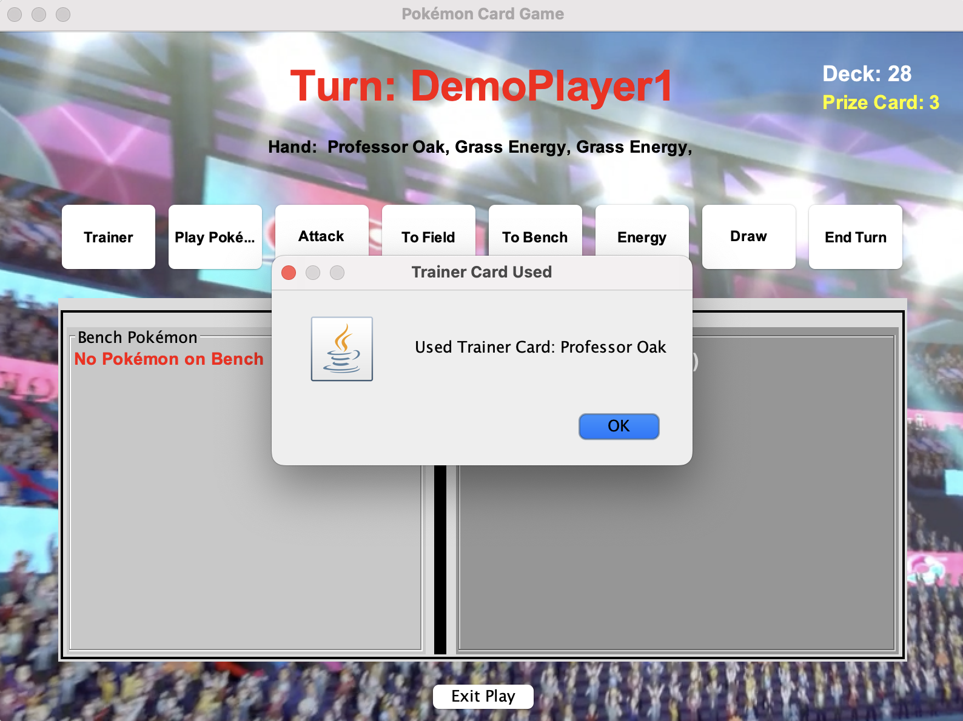

Trainer: Professor Oak

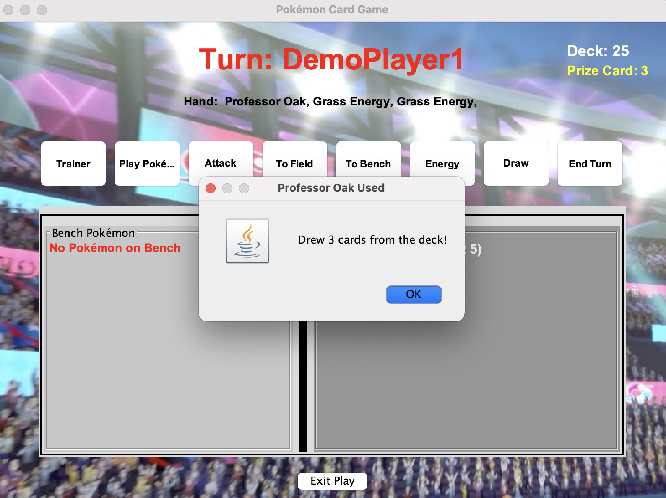

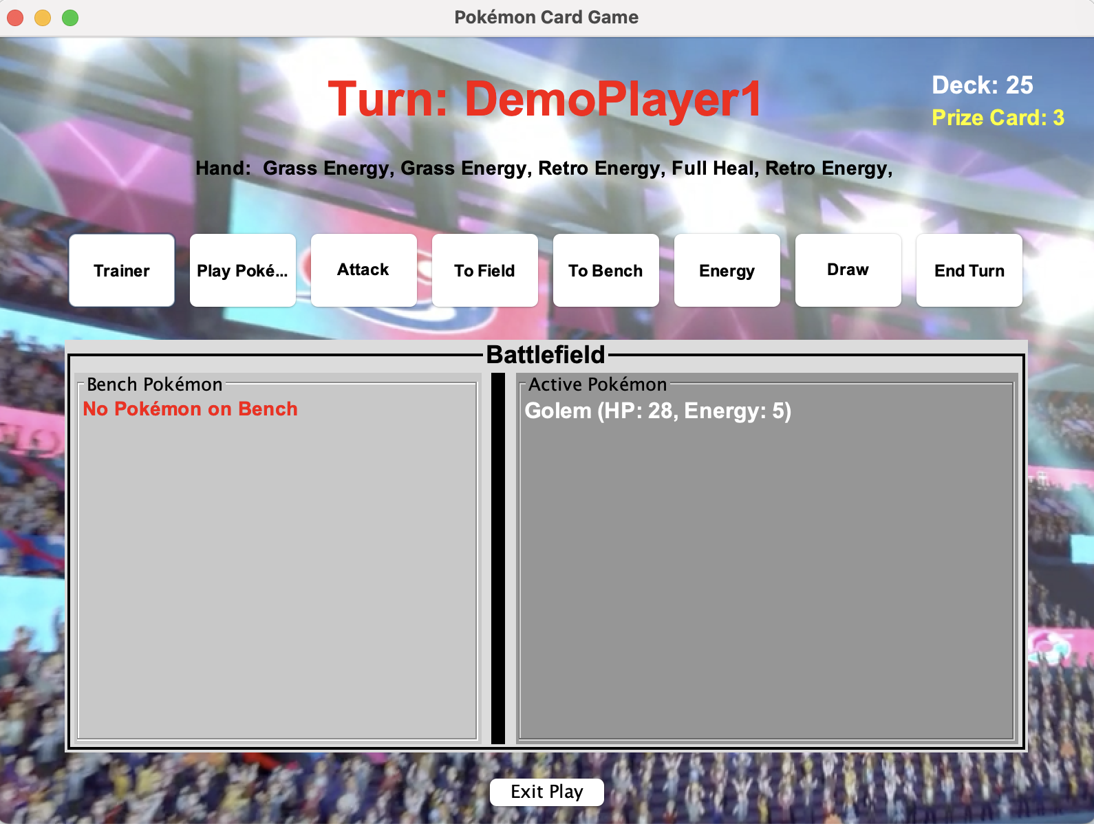

Professor Oak: draw 3 cards from deck

* Draw ( A random card is drawn from deck)

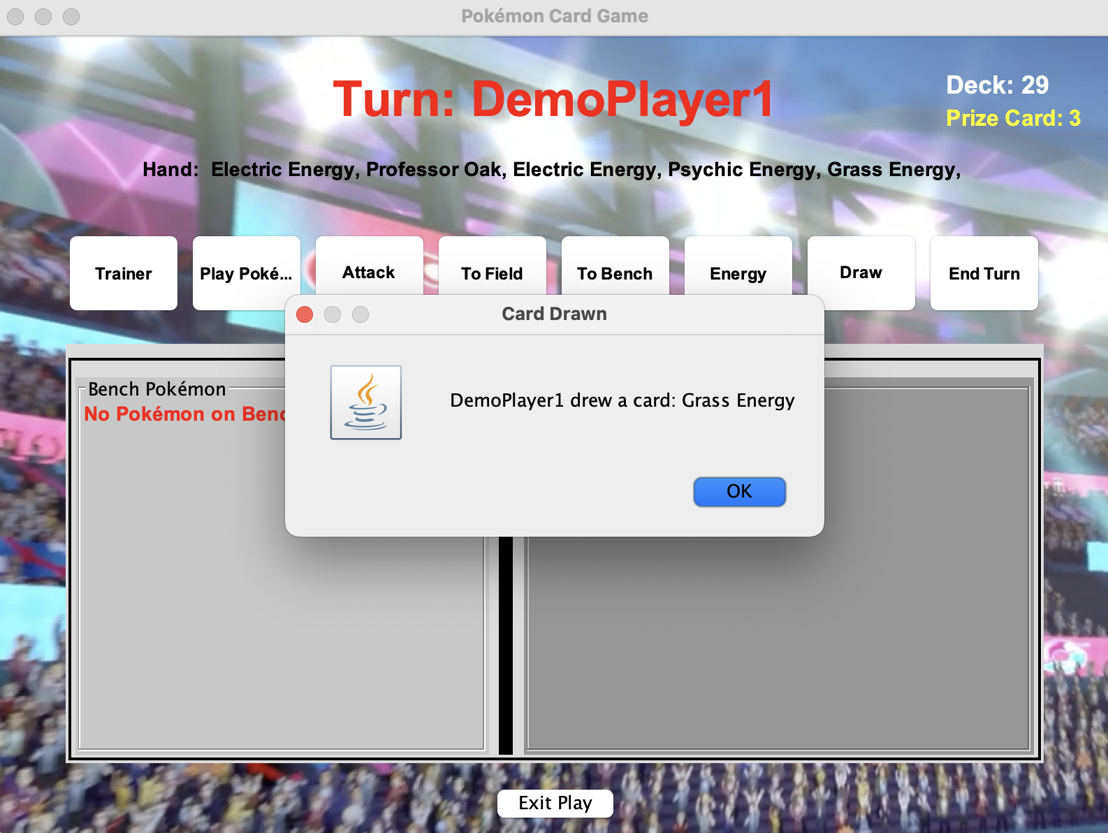

* Attack (Battles opponent’s Pokémon).



Use energy card to gain energy to attack

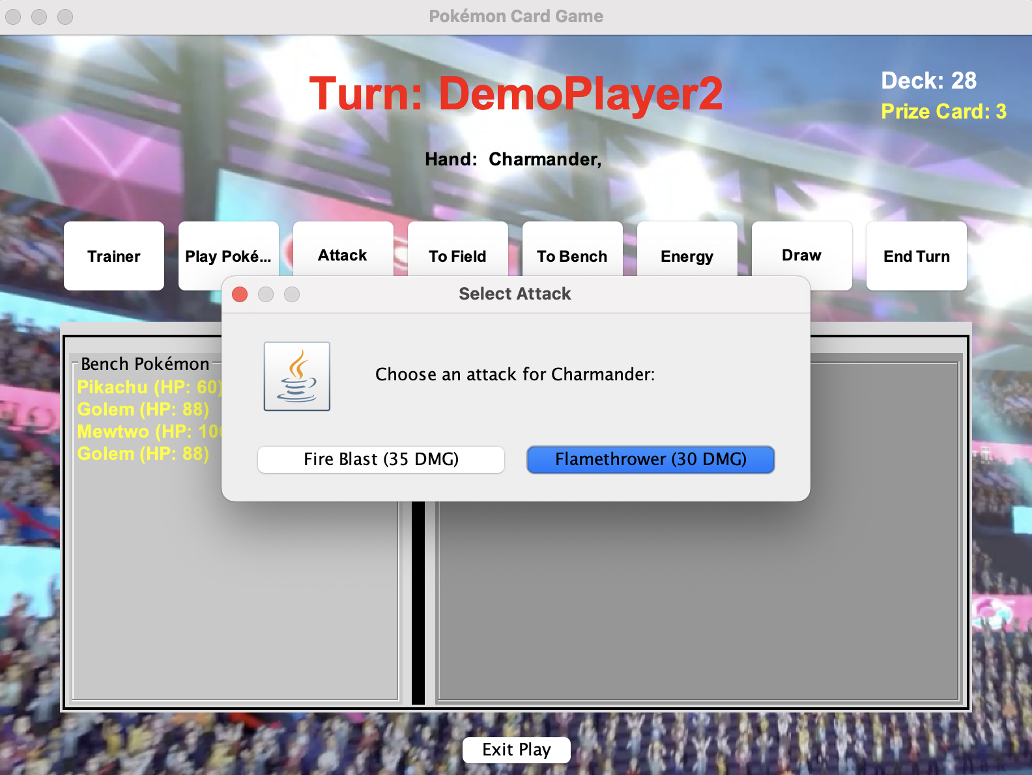

You can choose your attack

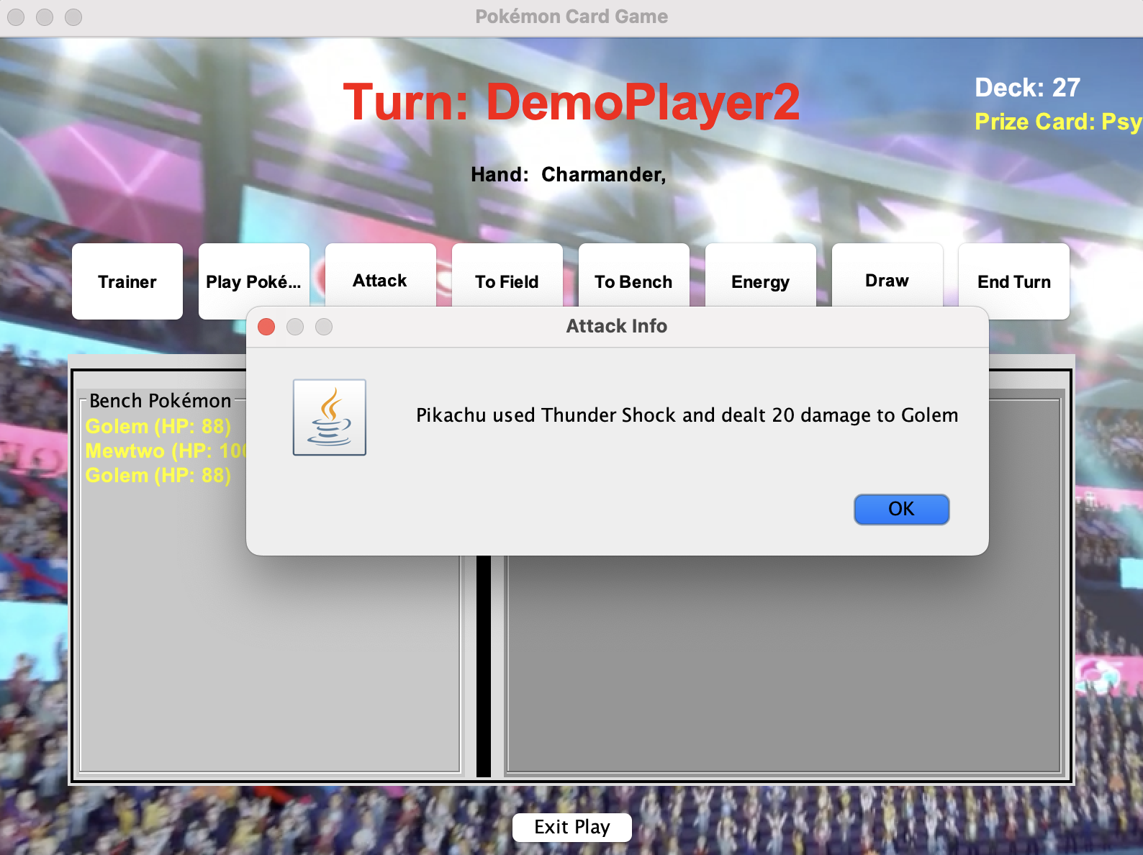

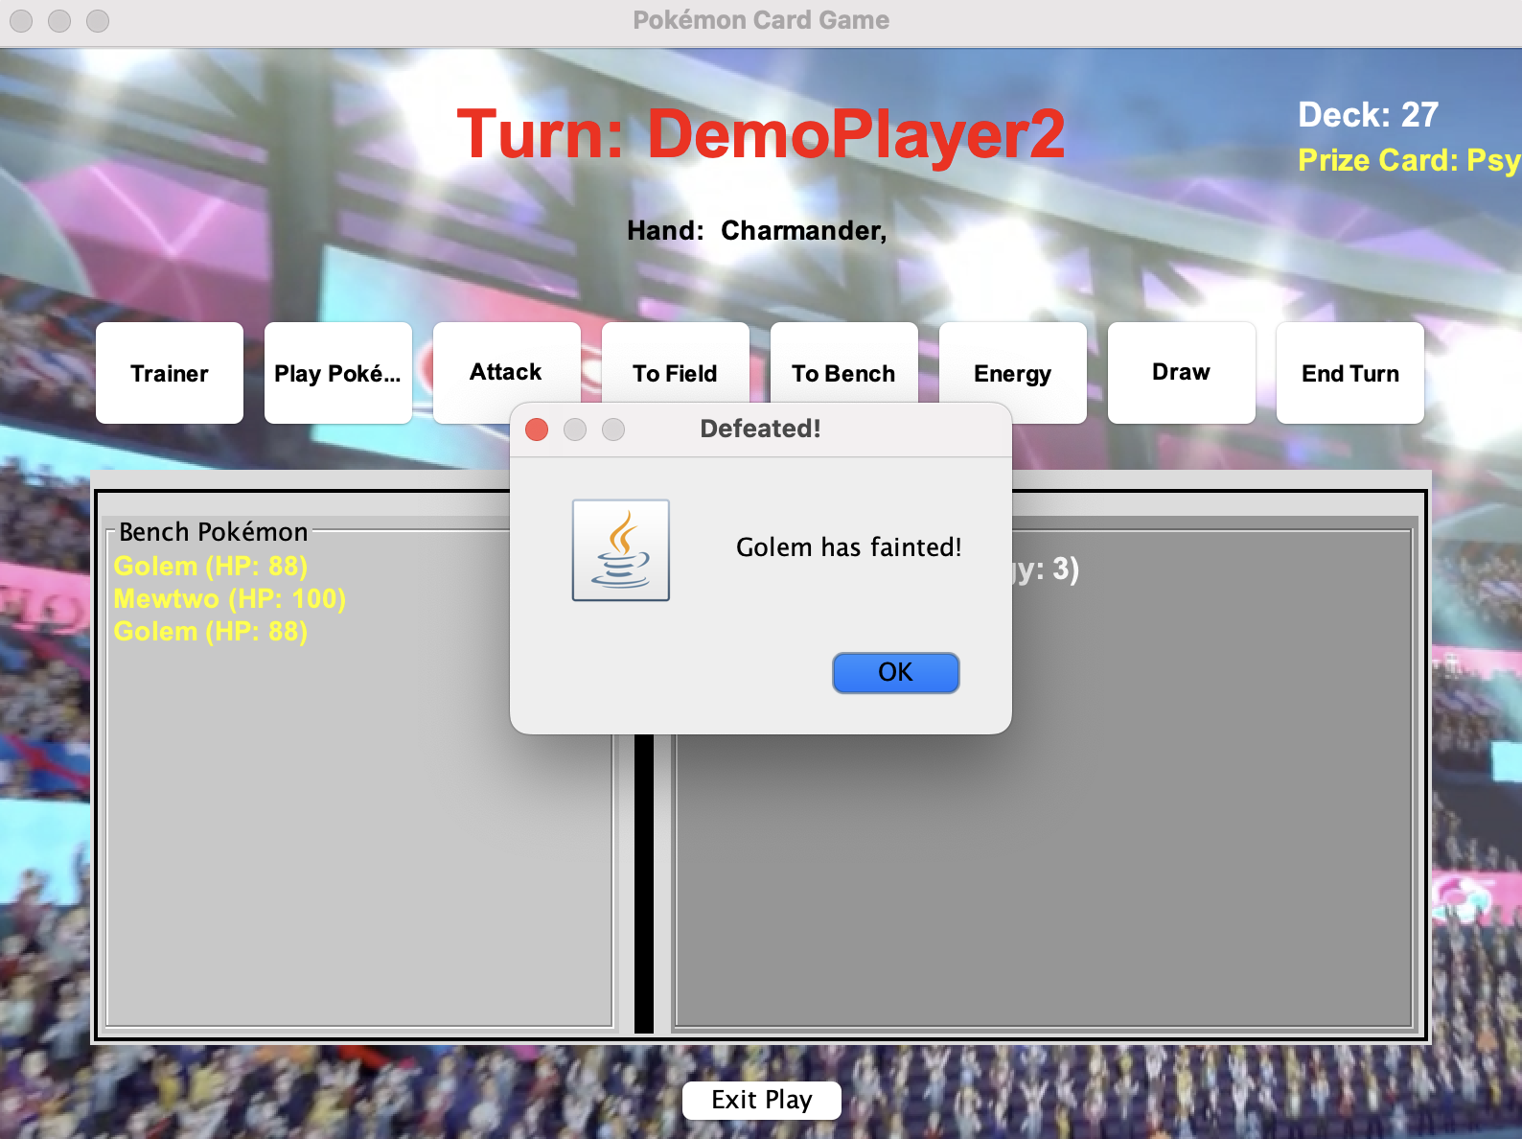

* End Turn (Passes turn to opponent after each attack).

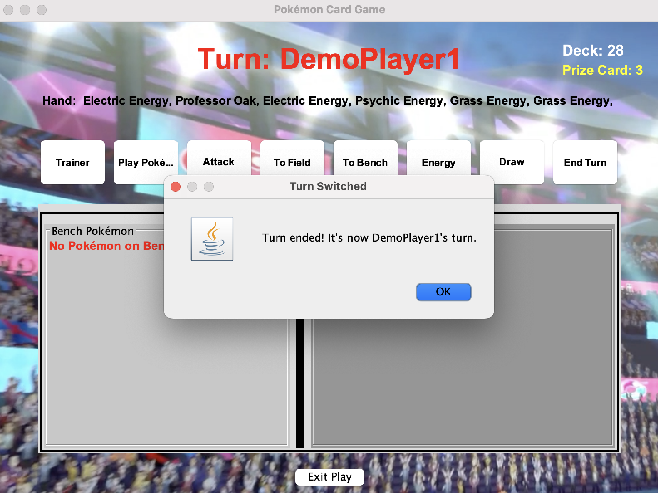

#### **6.4.4. Deck & Prize Card Display**

* Deck Counter: Displays the number of cards left.
* Prize Cards: Shows the amount left to claim.



## **8. Additional Notes**

* If a player has no Pokémon at the start, they reshuffle and redraw.
* If a player’s deck is empty, they lose.
* If an attack reduces HP to 0, that Pokémon is removed from play.
* Strategy matters! Use Energy and Trainer cards wisely.